PYTHON DATA STRUCTURES AND ALGORITHMS

TABLE OF OF CONTENTS:
Sequence types: String, Lists and Tuples
indexing --------------------------------------------------------------------------------------- 1
slicing ------------------------------------------------------------------------------------------1
concatenating via + ---------------------------------------------------------------------------3
multiplying using * ---------------------------------------------------------------------------3
checking membership ------------------------------------------------------------------------4
iterating through items in a sequence ------------------------------------------------------4
counting the number of item in a sequence------------------------------------------------5
finding the minimum of a sequence Lexicographically ---------------------------------5
finding the maximum of a sequence Lexicographically ---------------------------------6
finding the sum of items in a sequence ----------------------------------------------------6
sorting ------------------------------------------------------------------------------------------6
sorting by other than the first letter -------------------------------------------------------7
count(items) -----------------------------------------------------------------------------------7
Index(item) returns the index of the first occurrence of an item -----------------------8
unpacking lists --------------------------------------------------------------------------------8
list constructors -------------------------------------------------------------------------------8
deleting and appending to lists --------------------------------------------------------------8
inserting items in lists ------------------------------------------------------------------------8
popping items off of lists --------------------------------------------------------------------9
remove items off of lists ---------------------------------------------------------------------9
reversing lists ----------------------------------------------------------------------------------9
sort ----------------------------------------------------------------------------------------------9
tuple constructors -----------------------------------------------------------------------------10
modifying tuples ------------------------------------------------------------------------------10
set operations ----------------------------------------------------------------------------------11
mathematical set operations -----------------------------------------------------------------12
dictionary operations--------------------------------------------------------------------------13
iterating a dictionary -------------------------------------------------------------------------14
list comprehensions ---------------------------------------------------------------------------15

Stacks, Queues and Heaps
stacks---------------------------------------------------------------------------------------------16
queues --------------------------------------------------------------------------------------------17
heaps ----------------------------------------------------------------------------------------------18

Linked lists;
regular linked lists: ----------------------------------------------------------------------------22

Documentation:

indexing- access any item in the sequence using its index. Index starts with 0 for the first element (0 and not one relates to the memory address. The position also indicates the distance from the first element of the array)

#given the string:
x = “frog”
print(x[3])

yields g

#given the list
x -= [“pig”, “cow”, “horse”]
print(x[1])

yields cow

#given the tuple
x = (“kevin”, “nikolas”, “jenny”)
print(x[0])

yields kevin

Slicing
We can slice substrings, sublists subtuples:
[start: end +1 :step]
step ins an optional parameter, if it is not added it is assumed to be one.

x = “computer”
print(x[1:4])

Here step was not imputted, so it defaults to one. The first letter in the slice is “o” and the 4th letter (which is not included) is “u” so we onnly print from the first letter to the third. Hence this yields:

yields omp

print(x[1:6:2])

Here the optional parameter is “2”. So we count every two letters

yields “opt”

print(x[3:]) prints from 3 until the end

this yields: puter

print(x[:5]) yields from the beginning to the 4th item:
yields compu
print(x[-1]) yields the last element of the string
“r”

print(x[-3:]) yields from the third last position to the end of the string:

ter

print(x[:-2]) form the beginning of the string to the next to last position of the string:

comput

Concatenating Sequences of the same type by using +

x = “horse” + “shoe”
print(x)

horseshoe

x = [“pig”, “cow”] + [“horse”]
print(x)

[“pig”, “cow”, “horse”]

x = (“kevin”, “nikolas”) +( “jenny”,)
print(x)
(“kevin”, “nikolas”, “jenny”)

Important: for the last example , the second tuple must have a comma after the string! This tells python that this element is a tuple. Otherwise it will be considered a string in parenthesis!!

Multiplying Sequences by using the *
#string
x = “bug” * 3
print(x)

bug bug bug

#list
y = [5, 8] *3
print(y)
[5, 8, 5, 8,5, 8]

#tuple
z = (2, 4) *3
print(z)

(2, 4, 2, 4, 2, 4)

checking membership (testing if an item is in a sequence)

#string
x= “bug”
print (“u” in x)

yields True (checking membership always yields a boolean)

#list
y = [“pig”, “cow”, “horse”]
print( “cow” not in y)

yields False

#tuple
z = (“kevin”, “niklas”, “jenny”)
print(“Niklas” in z)

yields True

Iterating through items in a sequence
# item
x = [7, 8, 3]
for item in x:
print(item)

yields 7
8
3

#intex and item
y = [7, 8, 3]
for index, item in enumerate(y):
print(index, item)

yields: 0 7
1 8
2 3

can get both the index and the item with the enumerate function

#number of items: count the number of items in a sequence
(just use the len function)

#string
x = “bug”
print(len(x))

yields 3

#list
y = [ “cow”, “horse”, “pig”]
print(len(y))

yields 3

#tuple
z = (“Kevin”, “Niklas”)
print(len(z))

yields 2

Finding the minimum item in a sequence lexicographically
this is either alpha or numeric types but cannot be a mix of both

By minimum we mean the smallest on the ASCII scale

x = “bug”
print(min(x))

yields b SINCE b COMES FIRST ALPHABETICALLY

#list
y = [ “cow”, “horse”, “pig”]
print(min(y))

yields “cow”

z = (“Kevin”, “Niklas”, “Jenny”, “Craig”)
print(min(z))

yields Craig

Finding the maximum item in a sequence lexicographically
this is either alpha or numeric types but cannot be a mix of both

By maximum we mean the smallest on the ASCII scale

x = “bug”
print(max(x))

yields u

#list
y = [ “cow”, “horse”, “pig”]
print(max(y))

yields “pig” (SINCE PIG COMES LAST ALPHABETICALLY)

z = (“Kevin”, “Niklas”, “Jenny”, “Craig”)
print(max(z))

yields Niklas

Sum finding the sum of items in a sequence. Entire sequence must be numeric

#list
y = [2, 5, 8, 12]
print(sum(y))
print(sum([-2:])

yields 27 for the first print
yields 20 for the second print (just adding the last two items in the list)

#tuple
z = (50, 4, 7, 19)
print(sum(z))

yields 80

Sorting returns a new list of items in sorted order. Does not change the original list
#string

x = “bug”
print(sorted(x))

yields [“b”, “g”, “u”] RETURNS A (NEW) LIST
#list
y = [“pig”, “cow”, “horse”]
print(sorted(y))

returns [“cow”, “horse”, “pig”]

#tuple
z = (“kevin”, “niklas”, “jenny”, “craig”)
print(sorted(z))

returns [“craig”, “jenny”, “keving”, “niklas”] RETURNS A (NEW) LIST

If you wanted to sort by a different letter other than the first, you need to use a Lambda function
Add a key parameter and a lambda function to return the second characters

#tuple
z = (“kevin”, “niklas”, “jenny”, “craig”)
print(sorted(z, key=lambda k: k = k[1]))

returns [“Kevin”, “jenny”, “Niklas”, “craig”]

#tuple
z = (“kevin”, “niklas”, “jenny”, “craig”)
print(sorted(z)

count(item) returns count of an item

#string
x = “hippo”
print(x.count(“p))

yields 2

y = [“pig”, “cow”, “horse”, “cow”]
print(y.count(“cow”)))

yields 2

#tuple
z = (“kevin”, “niklas”, “jenny”, “craig”)
print(z.count(“kevin”)))

yields 1

Index item returns the index of the FIRST occurrence of an item

#string
x = “hippo”
print|(x.index(“p))

yields 2

#list
y = [“pig”, “cow”, “horse”, “cow”]
print(y.index(“cow”))

yields 1

#tuple
z = (“kevin”, “niklas”, “jenny”, “craig”)
print(z.index(“Jenny”))

returns 2

Unpacking lists:

Unpack: unpack the n items of a sequence into n variables.
Number of variables must match number of items in list.
To assign each variable to each item in the list.

x= [ “pig”, “cow”, “horse”]
a, b, c = x
print(a, b, c)

yields pig cow horse

Lists
-general purpose:
-most widely used data structure
- grow and shrink in size as needed
-sequence types
-sortable

creating lists done either by x = list() or x = []

del deletes a list or an item in a list:

x = [1, 2, 3, 4]
del(x[1])
print(x)

yields [1, 3, 4]

x[1] no longer exists

append - appends an item to a list
x = [1, 2, 3, 4]
x.append(6)
print(x)

yields [1, 2, 3, 4, 6]

Insert – insert an item into a given index
x = [1, 2, 3, 4]
x.insert(1,7)
print(x)
x.insert(1, [“a”, “m”])
first print yields [1, 7, 2, 3, 4]
second print yields 1, [“a”, “m”], 7, 2, 3, 4]

Pop method – pops last item off of list and returns item
x = [1, 2, 3, 4]
x.pop()
print(x)

yields [1, 2, 3]

print(x.pop())

yields 4

you can use the item that was popped off the list if you want to but you don’t have to.

Remove method -removes the FIRST instance of an item
x = [1, 2, 3, 4, 5, 3]
x.remove(3)
print(x)

yields [1,2, 4, 5, 3] the second 3 was note removed.

Reverse method; reverses the order of the list. It is an in-place sort, meaning that it CHANGES THE ORIGINAL LIST.

X = [1, 2, 3, 4, 5, 3]
x.reverse()
print(x)

yields: [3, 5, 4, 3, 2, 1]

Sort sorts the list in place
note: sorted(x) returns a NEW sorted list without changing the original list.

X = [5, 3, 8, 6]
x.sort()
print(x)

yields [3, 5, 6, 8]

reverse sort to sort list in descending order:
use reverse=True parameter in the sort function

X = [5, 3, 8, 6]
x.sort(reverse=True)
print(x)

yields [8, 6, 5, 3]

Tuples
-immutable
-useful for fixed data
-faster than lists
-sequence type

constructors: to create a new tuple use x = ()

example:

x = ()
x = (1, 2, 3)
x = 1, 2, 3

(strictly speaking parenthesis are not needed the commas are the most important parts

x = 2, (remember the comma otherwise python will see the 2 as an integer and not as a tuple

list = [1, 2, 3]
y = tuple(list)
print(y)

returns (1, 2, 3)

Tuples are immutable but member objects may be mutable. If I have a list as one of the objects inside a tuple I CAN make changes to that list.

For example:
x = (1, 2, 3)
del(x[1]) is not a valid operation.

But if we had x = (1, [2, 3], 4)
del(x[1][0]) to delete the 2 in the list this would work:
print(x)

printing the new tuple would yield: x = (1, [3], 4)

concatenating tuples:
we can’t add or append to tuples but we can use the “=” concatenation function:
y = (1, 2, 3)
y += 4,
print(y)
(1 ,2, 3, 4)

Sets
-sets store non duplicate items (ideal for unique items)
- very fast access compared to lists (item is hash)
-have lots of math set operations
- sets are unordered YOU CANNOT SORT A SET

to create new sets use x = {} or y = set()

EXAMPLE:

x = {3, 5, 3, 5}
print(x)

yields {3, 5} as there is no repetition in sets. Filters out the duplicates

list = [1, 2, 3]
y = set(list)
print(y)

returns {1, 2, 3}

set operations
can add an item to a set by using the add function:

x = {3, 8, 5}
x.add(7)
print(x)

yields {3, 8, 5, 7}

you can also remove items from a set using the remove function:
x.remove(3)
print(x)

yields {8, 5, 7}

you can also check for membership in a set:

print(5 in x)

yields True

getting the length of a set using the len function:
print(len(x))
yields 3

and you can pop off random items from a set.

print(x.pop(), x)

returns 8, {5,7}

finally you can delete all items from a set:
x.clear()
print(x)

yields {}

Mathematical operations in sets
- intersection (AND)
python uses the ampersand for this :
set_1 = {1, 2, 3}
set_2 = {3, 4, 5}
print( set_1 & set_2)

yields = {3}

- union (OR) python uses the vertical bar for this:
set_1 = {1, 2, 3}
set_2 = {3, 4, 5}
print( set_1 | set_2)

yields = {1, 2, 3, 4, 5}

-symmetric difference (exclusive or XOR) items that are in set_1 but not in set_2 or in set_2 but not in set_1 uses the ^

set_1 = {1, 2, 3}
set_2 = {3, 4, 5}
print( set_1 ^ set_2)

yields {1, 2, 4, 5}

set difference in set_1 but not in set_2 uses the – sign

set_1 = {1, 2, 3}
set_2 = {3, 4, 5}
print( set_1 - set_2)

yields {1, 2}

We can also check if one set is a subset of another
subset (set_2 contains set_1) set_1 <= set_2
superset (set_1 contains set_2) set_1 >= set_2

print( set_1 – <= set_2)
print( set_1 >= set_2)

both yield False

Dictionaries
-key value pairs
-associative array, like Java hashmaps
-dicts are unordered (cannot be sorted, but can be converted as a list and sorted as a list.

Constructor = x= dict() or {}
x = { “pork”: 25.3, “beef”:33.8, “chicken”:22.7}

this is an alternative way to construct a dictionary, where we pass in a list of tuples
x = dict([(“pork”, 25.3), (“beef”, 33.8), ( “chicken”, 22.7)])

this is a third way to construct a dict. There are no strings here that enclose the keys as python already knows that they are strings
x = dict((pork=25.3, beef=33.8, chicken=22.7)

Dict operations
adding: (or updating). Python will not tell you if that was in there already! You have to check that yourself first, by seeing if “shrimp” in dict()

x[“shrimp”] = 38.2
print(x)

yields { “pork”: 25.3, “beef”:33.8, “chicken”:22.7, “shrimp”: 38.2}

deleting an item (like deleting the shrimp)

del(x[“shrimp”])
print(x)

yields {“pork”: 25.3, “beef”:33.8, “chicken”:22.7}

to figure out the length of the dictionary and see how many key value pairs are there just use the len function.

deleting all items from a dict x
x.clear()
print(x)

yields {}
finally, to delete a dictionary and free up the memory that it was using, use the delete command:
del(x)

accessing keys and values in a dictionary
(not compatible with python2)

x={“pork”: 25.3, “beef”:33.8, “chicken”:22.7}
print(x.keys())

yields dict_keys([“pork”, “beef”, “chicken”])

print(x.values())
yields dict_values([25.3, 33.8, 22.7])

print(x.items())
yields dict_items([(“pork”, 25.3), (“beef”, 33.8), (“chicken”, 22.7)])

#check membership in x_keys (only looks in keys, not values)
to check membership in just the keys you do not have to specify x.keys but you can

print(“beef” in x)
returns True

# check membership in x_values
print(“clams” in x.values()) returns False

iterating a dictionary (note, items are in random order)

here are two ways:
for key in x :
print(key, x[key])

returns pork 25.3
beef 33.8
chicken 22.7

for k, v in x.items():
print(k, v)

returns pork 25.3
beef 33.8
chicken 22.7

list comprehensions
allows us to put an iteration in a list generator to generate a list. Basic format:
new_list = [transform sequence [filter]]

here we will use the list comprehension:

getting values within a range
under_10 = [x for x in range(10)]
print (“under_10”: + str(under_10))

result = under_10 = [1, 2, 3, 4, 5, 6, 7, 8, 9]

get squared values:

squares = [ x**2 for x in under_10]
print(“squares:” + str(squares))

result = squares: [0, 1, 4, 9, 16, 25, 36, 49, 64, 81]

get odd numbers using mod:
odd [ x for x in range(10) if x % 2 == 1]
print( “odds:” + str(odd))

result odds: [ 1, 3, 5, 7, 9]

get multiples of 10

ten_x = [ x*10 for x in range(10)]
print( “ten_x” + str(ten_x))

result ten_x: [10, 20, 30, 40, 50, 60, 70, 80, 90]

get all numbers from a string
s = “ I love 2 go t0 the store 7 times a we3k”
nums = [ x for x in s if x.isnumeric()]
print( “nums: ” + “ ”.join(nums))

result = 2073

get index of a list item

name = [“Cosmo”, “Pedro”, “Anu”, “Ray”]
idx = ( x for x, y in name enumerate(names) if v == “Anu”]
print(“index =” + str(idx[0]))

yields index = 2

delete items off a list

letters = [x for x in “ABCDEF”]
random.shuffle(letters)
lettrs = [ a for a in letters if a != “C”]
print (letters, lettrs)

result = [“D”, “F”, “E”, “A”, “B”, “C”] [“D”, “F”, “E”, “A”, “B”,]
here we have randomly shuffled letters in a list, and created a new list that filters out the “C”

MORE ADVANCED DATA STRUCTURES: STACKS QUEUES AND HEAPS

STACKS
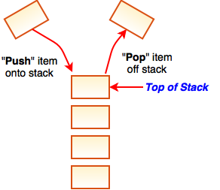
a stack is a last in first out (LIFO) data structure·

all the push and pop operations affect the top of the stack
The only way to access the rest of the items in the stack is to first remove all the items above it.

Key operations: -push allows you to put an item on top of the stack.
-Pop allows you to pop an item off of the stack
- peek allows you to look at the top item of the stack without actually removing it from the stack.
-clear to clear all items from the stack and empty the stack

Stack use Case
lots of computer programs track which commands you are doing. They have a command stack.
To undo a command you use the stack
Undo -track commands which have been executed. Pop off last command off command stack to undo it.

Stacks using the python list
-stack is an LIFO data structure –last in first out
-use append() to push an item onto the stack
-use pop() to remove an item
my_stack = list()
my_stack.append(4)
my_stack.append(8)
my_stack.append(77)
my_stack.append(12)
print(my_stack)

yields [7,8, 12, 77]

print(my_stack.pop())
print(my_stack.pop())
print(my_stack)

yields 77
12
[7,8]

The pop() method in the python list does exactly what we want: it pops off the last item of the list.

Stack using List with a wrapper class
we can create a stack class and a full set of stack methods. But the underlying data structure is really a python list.
For pop and peek methods we first check if the stack is empty to avoid exceptions:

class Stack():
def __init_(self):
self.stack = []

def peek(self):
if len(self.stack) < 1:
return None
return self.stack[-1]

def pop(self):
if len(self.stack) < 1:
return None
return self.stack.pop()

def push(self,item):
self.stack.append(item)

def __str__(self)
return str(self.stack)

QUEUES
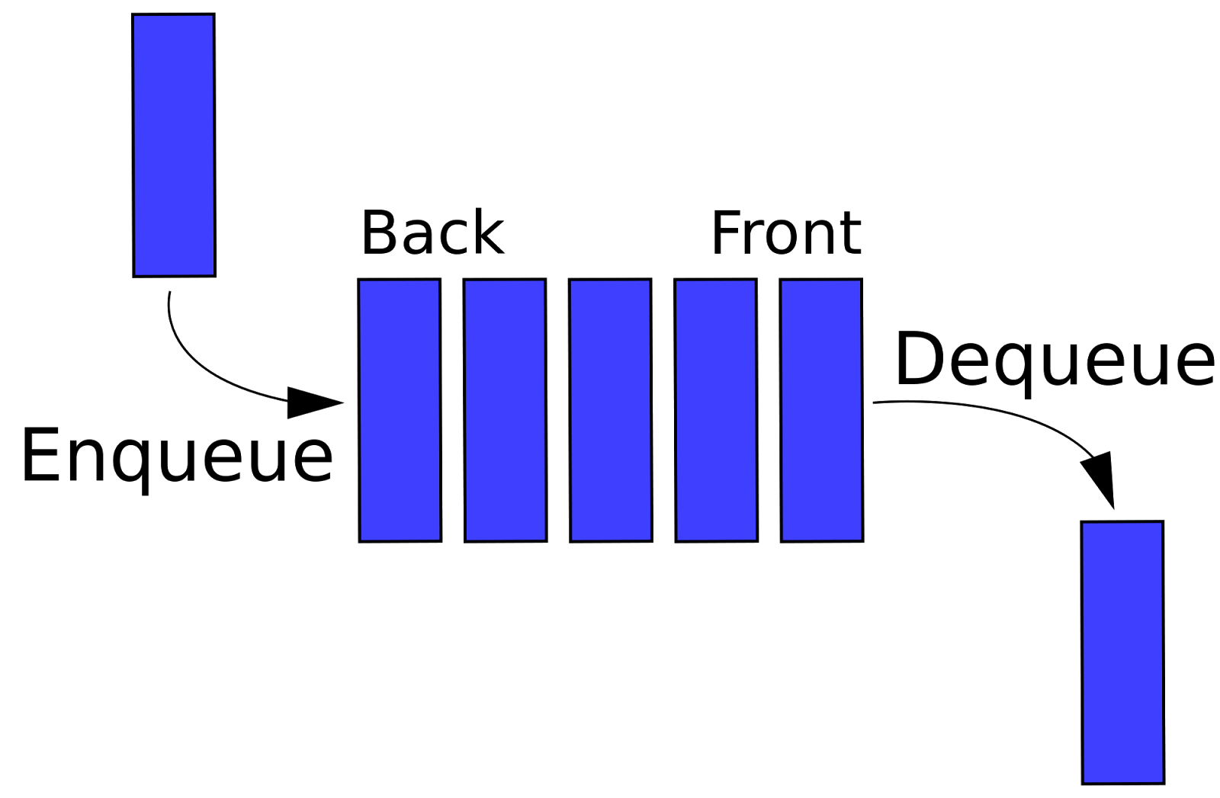
A queue is a first in first out (FIFO) data structure.

We enqueue to add an item to the end of the line, and dequeue to remove an item from the front of the line.

Fortunately python has a built in library that deals with queues.

This is called the Deque library.

It allows us to create Deques a double ended queue though we can use it for any queue. We use append() to enque an item and popleft() to dequeue an item:

from collections import deque

my_queue = deque()
my_queue.append(5)
my_queue.append(10)
print(my_queue )
print(my_queue.popleft())

this yields: deuque ([5, 10])
5

Queue using List with a wrapper class

from collections import deque

class Queue():

def __init__(self)
self.queue = deque()

def enque(self, item):
self.queue.append(item)

def dequeue(self):
if len(self.queue) < 1
return None
self.dequeue.popleft()

PYTHON MAX HEAP
What is a max heap?
-It is a complete Binary tree (more on that later).
- the underlying data structure is a list
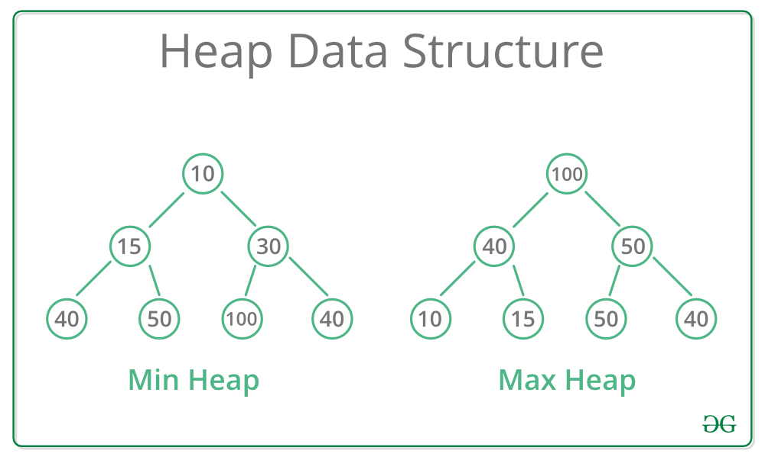
-The one condition of the max heap is that every node is less than or equal to its parent. So 100 is greater than its children (40 and 50). For min heaps every node is greater than or equal to its parent

Max heaps are very FAST!

-Insert in O(log(n))
-get max in O(1)
--Remove Max in O(log(n))

(this is all with respect to time)

You can implement Max heaps in Python using a list.

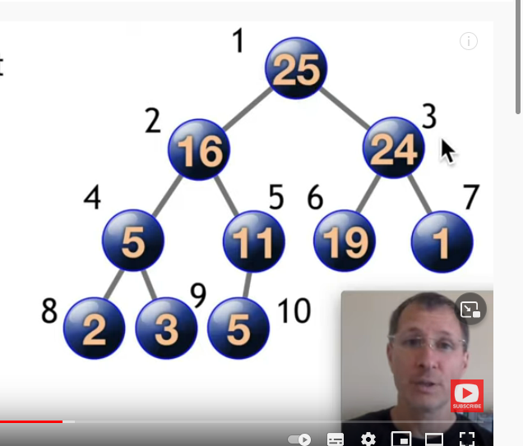
In the maxheap, the greatest number is assigned the first index of the list. The going across from left to right, the other items of the heap are indexed.

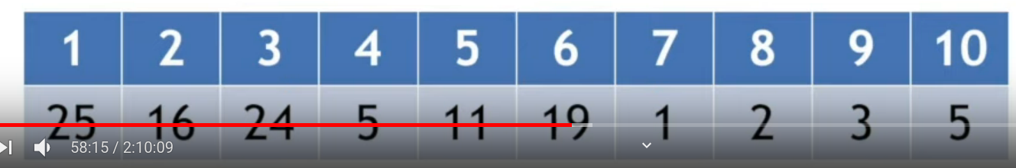
So 2 sits at position 8. to access its parent we simply divide the index by 2,and see that the parent of 2 is 5 which sits at position 4 . If the number were odd (say 3 sitting at position 9 , we simply divide and 2 and round down (so 9/2 = 4,5, round down = 4)

Thus parent(i) = i/2
leftchild(i) = i*2
rightchild(i) = (i +0.5) *2

Max Heap operations

-push (insert)
-peek(get max)
-pop (remove max)

Lets first look at push:
-Add a value to the end of the array
-float it Up to its proper position

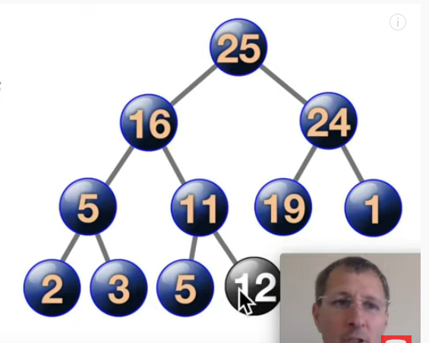
for example, if we want to push 12 on the heap. We will first put it at the end of the heap, where it will be the child of 11, at the last index of the array:

And then we need to float it up to its proper position.
And how do we do that?

Well, we need it compare 12 with its parents.
So ask if 12 > 11?
And if it is, we will have 12 and 11 swap places.
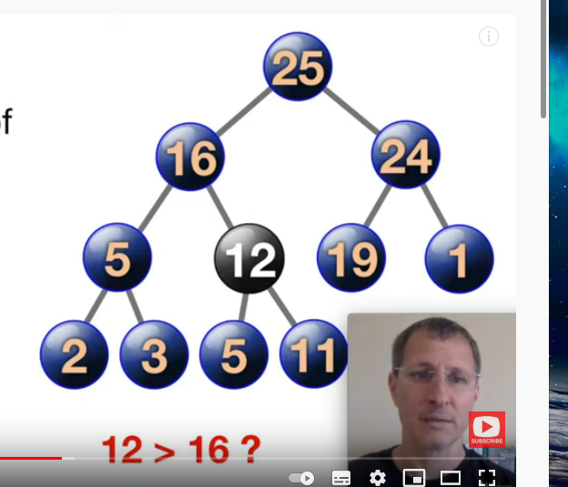
Then we rinse and repeat. Now the parent of 12 is 16 and we compare if 12 is greater than 16. As it is not, we do not swap places.
There is no more swapping, 12 has already arrived at its appropriate position.

Thus, when we add an item to the heap, we need to be able to use “float it up” into is proper place using the “floatup” or “bubbleup” function that we will need to code.

The peek function is easy.
Peek just returns the first item of the heap. Thus heap[1]

As for the pop function, we will need to do a couple of things:
-move the max to the end of the array
-delete it
-bubbledown the item at index 1 to its proper position
-return max

So suppose that we want to remove 25. As 11 is in the last position of the heap,. We first swap 25 and 11. This way we can safely remove the 25 without affecting the rest of the heap

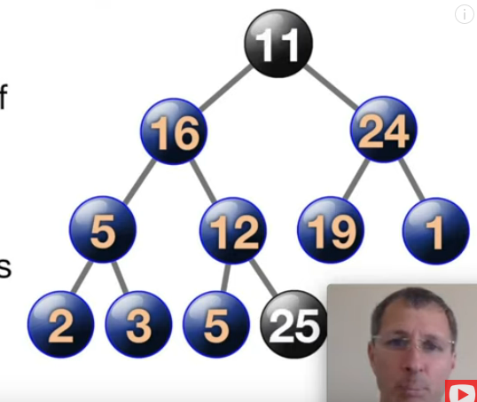
Next we need to bubble down the 11 by comparing it to its children.
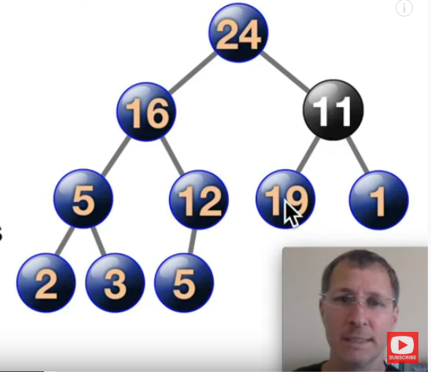
So here we are asking the question of “is 11 > 24?” As it isn’t we swap 11 and 24. And as 11 is less than 19 we swap it with the 19.
And now 11 can’t go further down and nothing else needs moving.

Python Max Heap
- a MaxHeap always bubbles the highest value to the top so it can be removed instantly.
Public functions: push, peek, pop
private functions (functions we need interally to code push, op and peek; theya re not apart of the user interface). : swap, floatUP, __bubbledown, __str

defining a wrapper class for the max Heap

class MaxHeap:

def __init_(self, items=[]):
super().__init__()
self.heap. = [0] #we put a 0 as the first element because we don’t use that, need list to start at index 1)
# for each item we create we then need to push it up to its proper position)
for item in items:
self,heap.append(item)
self.__floatUp(len(self.heap)-1)

def push (self, data): #same as the constructor code, but for just 1 item we are adding
self.heap.append(data)
self.__floatUp(len(self.heap) -1)

def peek(self):
if self.heap[1]
return self.heap[1]
return False

def pop(self):
if len(self.heap)>2:
self.__swap(1, len(self.heap) -1)
max = self.heap.pop()
self.__bubbledown(1)
elif len(self.heap) == 2:
max = self.heap.pop()
elif:
max = False
return max

an this is the outline of the class. We now need to define the private functions, swap, bubbledown and floatup that we will need to add to the class:

def swap (self, i j):
self.heap[i],self.heap[j] = self.heap[j], self.heap[i]

def __floatUp(self, index):
parent = index//2
if index <=1: (if it is already in the top position then there is not floating up to do)
return
elif: self.heap[index] > self.heap[parent]: otherwise we will compare it to its self.__swap(index, parent)
self._-floatUp(parent)
parent, and it it is greater than its parent we will swap places. Then we will ca the float up function recursively until it reaches the proper position.

def _-bubbleDown(self, index):
left = index * 2
right = index * 2 + 1
(getting the left child and the right child by mutliplying the index by two and two and adding 1
largest = index
#then we do a little comparison. If the item we are bubbling down is less than their right child, we #are going to swap positions with the right one

if len(self.heap) > right and self.heap[largest] < self.heap[right]:
largest = right
#if the item we are bubbling down is less than the left child we are going to swap positions with the #left one

if len(self.heap) > left and self.heap[largest] < self.heap[left]:
largest = right

if largest != index:
#last thing we do is check if there is any swapping that needs doing, and then call recursively the bubble down function until the item has bubbled down.
self.__swap(index, largest)
self.bubbleDown(largest)

one can change this code by changing a couple of less than and greater than signs to implement a min heap

regular linked list!

Every linked list is composed of nodes. Each item in a linked list is node. Each node is connected to the next node. Each node has 2 parts: data and a pointer to the next node.

